Assignment 2 -Group 3

Qinqing Peng (qpen0175), Sheng yUAn (SYuA5465), Haoran Liu (hliu4246)

TUTORS: HARRISON NGUYEN, ASWANI KUMAR

2018

Table of Contents

Abstract 2

Introduction 2

Previous work (Literature review) 3

1. Pre-processing 5

**1.1 One hot encoding** 5

**1.2 PCA** 5

**1.3 Normalization** 6

2. Classification Methods 6

**2.1 Logistics regression** 6

**2.2 KNN** 7

**2.3 Random forest** 8

3. Validation Method – K-fold cross validation 9

Experiments and Discussion 9

1. Execution configuration 9

2. Procedures description 9

3. Results and Comparison 10

**3.1 Results** 10

**3.2 Comparison and Discussion** 16

Conclusion and Feature work 18

Appendix 21

# **Abstract**

In this report, the cover type dataset was selected by our group. We applied 3 classification methods as KNN, Random Forest and Logistic Regression to predict 7 forest types. Our focus on both improving the accuracies of the classifiers and comparing the performance of them. Corresponding to the data pre-processing methods, one hot encoding, normalization and Principle Component Analysis (PCA) were selected to apply control variable method to analyse how each method influences on the overall results of each classifier.

# **Introduction**

* What is the problem you intend to solve?

This assignment is to solve a real-world problem by applying machine learning and data mining

methods. The target is to select 3 types of classifiers to classify a chosen dataset

and compare their performance. Cover type dataset was selected by our group. This is a

textual dataset in the UCI Machine Learning Repository which recorded the forestay data

from 4 wild areas in Roosevelt National Forest in northern Colorado, USA. It contains

581012 instances, each one has 12 attributes, separated in 7 classes. After literature

reviewing, Logistic Regression, Random Forest and KNN were selected. To apply these

classifiers, Sklearn library will be utilized. Meanwhile, various parameter adjusting

progress and data pre-processing methods are applied.

* Why is this problem important?

The problem is to classify the different forest cover types by analysing their features.

This research has great potential in forestry and geography. In the research of Thomas

and Aravind [1], they indicated to improve the performance of classifier on this kind of

problems can help to increase the efficiency of investigating in wild environment in the

field of forestry and relevant organizations such as USFS (US Forest Service). [1] For

example, a fine-grained classifier for this dataset can do transfer learning to other forest

datasets in the other locations. In addition, some institutions, such as Kaggle, will have

competitions to collect ideas from participants for future researches.

# **Previous work (Literature review)**

The cover type Dataset is a famous and traditional dataset which was collected in 1998 in the UCI machine learning repository. Many researchers concentrating in machine learning chose this dataset to test the performance of the classifiers they designed. Therefore, referring to previous work, before designing the new classifiers, would be helpful for the future researchers. This part will introduce a study on this dataset by Thomas, Aravind. In addition, some algorithms from Hugo Sjoqvist’s study will also be introduced.

Thomas and Aravind, who are researchers from NYC Data Science Academy, did a study on a competition hosted by Kaggle [1], which selected a training set of 15120 observations and a test set of 565892 observations. Such a large data size made this classification task very challenging. In this study, the researchers decided to use packages of machine learning and visualization in R language. This study covers not only the processes of designing classifiers and comparison of the results, but also a professional investigation of all important attributes including elevation, aspect, slope and others of the dataset. For example, by the visualization of the distribution of all classes in the scale of elevation, the elevation distribution diagram was generated:

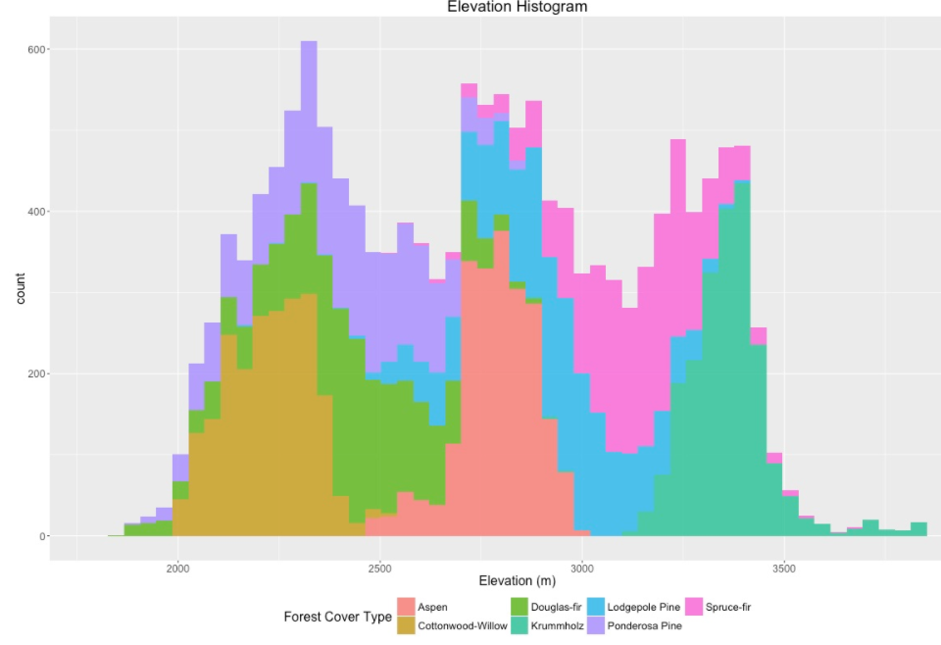

**Figure 1. Elevation distribution diagram [1]**

In this diagram it can approximately find that the train data was equally distributed among the 7 classes. [1] Besides, it can prove the elevation is a reliable parameter to classify the cover type. For example, the Cottonwood Willow plants can only exist in the range of about 2000 to 2500 meters elevation in this training set. Furthermore, Thomas and Aravind analyzed all attributes existing in the dataset and plotted figures for them.

Apart from this, they also combined the influence of attributes to synthetically analyse the characters of each class such as in Figure 2, Hillshade_9am, slope and elevation have been analysed together by building a 3-dimension Cartesian coordinate.

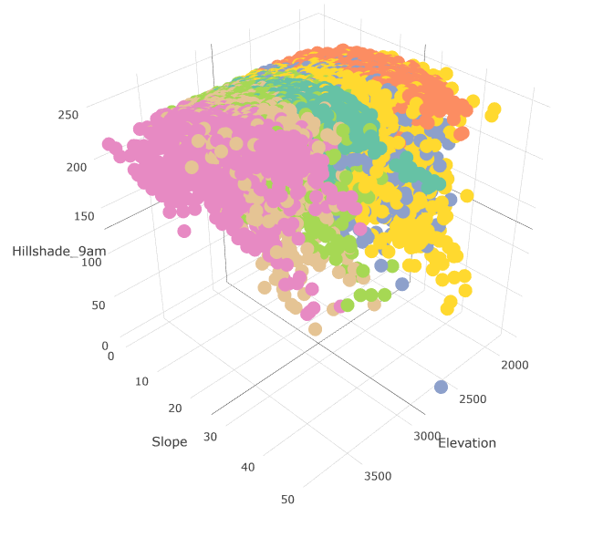

**Figure 2. Elevation distribution diagram 2 [1]**

In the modelling part, they applied 3 methods: Multinomial Regression, Neural Networks and Tree based methods (Random Forest and etc.). The Multinomial Logistic Regression based on the original dataset. However, the others are based on both the original dataset and the Feature Engineering. Feature Engineering is a method to pre-process on the original attributes. For example, the values of the elevations were transformed to the logarithm forms as ‘log_elevation’. This will improve the accuracy of Neural Networks and Tree based methods.

In the part of Logistic Regression, Lasso regularization and Ridge regularization performed as the data pre-processing. To concurrently use both can produce an elastic-net regularization. Finally, the best accuracy will attain 59.59%. [1] For neural network, a 54-100-7 node neural nets on training data achieved 52.11% accuracy for 300 max iterations and 52.43% for 500 max iterations. The other methods were not considered to be reference in this assignment.

For the research of Hugo Sjoqvist, it is much simpler in data analysis and visualization, but the methods are quite different. Support Vector Machine, Naiver Bayes and Decision Tree. The data pre-processing methods are a little bit different. Random Forest selection, Lasso and PCA were picked. [2]

For overall accuracy, SVM got 89.1% under RF selection, but only 81.8 by Lasso; NB got 66.8% after Lasso, but only 48.0% after PCA; finally, for Random Forest, after PCA it owned 94.7% accuracy, but 75.2% after Lasso. [2]

These 2 articles are a part of literatures referred by this assignment. The detailed methods could be very different for optimizing the accuracy and comparing the performance.

**Methods**

## **1. Pre-processing**

### **1.1 One hot encoding**

One hot encoding is a process that convert categorical variables with N-state into a N-bits representation form while only one bit is 1, which makes machine learning classifier perform a better job in prediction [3]. For example, in the Covtype data set, the Wilderness Area and Soil Type are already in one hot encoding format. Moreover, the Cover type, containing 7 types, can be also represented in one hot encoding format rather than in form of 1 to 7. For example, for the first cover type, we would transfer it to one hot encoding as [1, 0, 0, 0, 0, 0, 0], for the third cover type, we would transfer it to one hot encoding as [0, 0, 1, 0, 0, 0, 0] and etc.

### **1.2 PCA**

Principle component analysis (PCA) is a popular method to dimensionality reduction and to overcome the curse of dimensionality. The curse of dimensionality is that if the number of a data set’s features is significantly exceeding the number of samples, the classification model will be over complicated, and prediction might be overfitting [4]. By applying PCA, the features of the data set can be maintained. The following section introduces the steps of the PCA algorithm [5].

The explained variance is a significant aspect for the PCA performance and can be used to find the optimal component number. The total explained variance is defined as the sum of the variances of each component, which shows the feature reservation percentage of the original data set [6]. Hence, for K principal components analysis, the total explained variance is:

### **1.3 Normalization**

Data normalization is a feature scaling method, which can rescale the attributes to the range from 0 to 1 in general or other range with given minimum and maximum number. It is beneficial when the data set has a wide range of values. For instance, if one of the features has enormous value compared with others, it will definitely dominate the prediction of classifiers, which implement the Euclidean distance, such as KNN. Moreover, it is reported that the gradient descent converges perform faster with normalization [7]. The process of the normalization is:

## **2. Classification Methods**

### **2.1 Logistics regression**

Logistic Regression is a traditional method for classification. Initially, this method was applied to binomial classification problems. It requires that the output label y will only be y ∈ {0, 1} by the input prediction value .

To achieve this goal, an activate function – sigmoid function was taken into use. The form of sigmoid function is:

This activate function has 2 main advantages. Firstly, it can limit the output values of y in the range of {0, 1}, which can be equally divided buy the y axis and the point (0, 0.5). It can be clearly observed in Figure 3. When y is under 0.5, it will be label 1; when y is over 0.5, it will be label 2. Meanwhile, without applying sigmoid function, the cost function will always be non- convex (Figure 4). This is will be very hard to utilize the gradient decent to reach the global minimum. The sigmoid function can transform the function to be convex, which is easy for iteratively gradient decent.

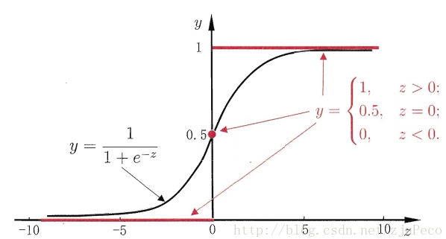

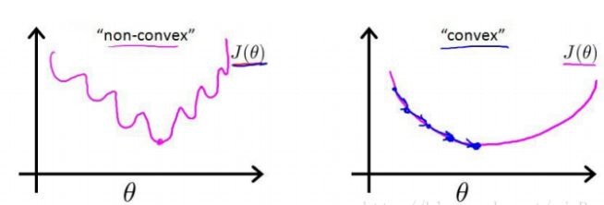

(Ref: <https://blog.csdn.net/zjuPeco/article/details/77165974>). (Ref: <https://blog.csdn.net/zjuPeco/article/details/77165974>)

**Figure 3. The figure of sigmoid function Figure 4. The non-convex and convex function diagrams**

The cost function is a critical concept in Logistic Regression. The basic theory is to fit the curve represented by the model to the values of training dataset by updating weights. The cost function is to reduce the loss between the original training dataset and the curve. The cost function:

To reduce the cost, gradient decent method is commonly used. The general process is locating the start points on the cost function curve and initializing a learning rate, then process the gradient decent iteratively and refresh the input theta values (weights):

For the iteration, it repeats

to get the .

### **2.2 KNN**

As for classifier selection, we decided to perform k-nearest neighbours, which is also called KNN algorithm. In the KNN classifiers, there are three required elements: store records, distance measure and a value of k.

In the conventional procedure of KNN, the nearest k neighbours should be found so that it would be classified to the corresponding record. Then a rule (e.g. by majority decision rule) would be used in order to classify the record. In this process, the record is classified as one of the majority class of the k neighbours. Among all the steps, the most crucial step for KNN algorithm is to measure the distance. Euclidean Distance is the most popular method to be performed and the predictors should be standardised or normalised in this procedure [8]. The Euclidean Distance can be calculated as below (Suppose record #1 (, ,…,) and record #2()):

Euclidean Distance = 

Choosing value of k would also have obvious impact to the classification. Higher values of k can help the model with alleviating overfitting. When k = n-1, the classifier performs the same rule as naïve rule. When k=1, which is the simplest case for KNN algorithm, it would still be very powerful classification tool, especially when we have large number of record. Overall, the selection for value of k should be based on which k has the best performance of classification.

### **2.3 Random forest**

Random forest is one of the most powerful machine learning classification algorithms, which was firstly introduced by Ho in1995 and finally developed by Breiman in 2001[9]. As its name random forest, it is an integrated model with a number of decision trees to create the forest.

Decision trees is a top-down approach, where the tree structure is constructed by different types of nodes. Starting with the root node, the process generates a binary split in each node based on the attributes and it is executed until it meets the terminal criteria. Finally, the end node represents the predicted outcome, or the predicted class. The node splitting is the significant part of the decision trees, which can be achieved by implementing methods such as the Gini impurity [10].

The random forest algorithm applied a technique called bagging [11]. Firstly, it separates the dataset into K numbers bootstrap samples. Each random subset creates a decision tree. Hence, for each test data, it has several possible outcomes corresponding to each decision trees. To make a prediction, the class with the highest number is selected. In general cases, the higher number of trees will provide a higher accuracy results [12]. The diagram of random forest classifier is shown in the Figure 5.

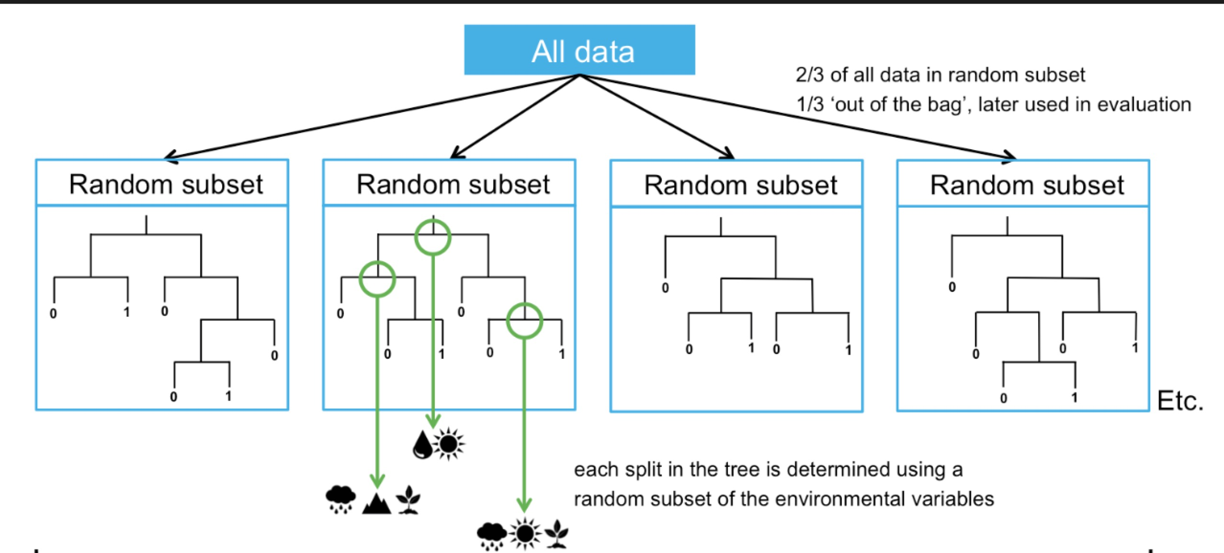

Ref: (https://support.bccvl.org.au/support/solutions/articles/6000083217-random-forest)

**Figure 5. Random forest classifier diagram**

## **3. Validation Method – K-fold cross validation**

In K-fold cross validation, the original data set is split randomly into K subset. In each time, one of them is used as the test data set and the remaining K-1 subset are used as the training data set. This process will repeat K times. The main benefit of this method is that the whole data set are used for both training and validation purpose, while each observation is only used for validation once.

# **Experiments and Discussion**

## **1. Execution configuration**

**Hardware**

* MacBook Pro (13-inch, 2017, Two thunderbolt 3 ports)
* Processor 2.3 GHz Intel Core i5
* Memory 8 GB 2133 MHz LPDDR3
* Graphics Intel Iris Plus Graphics 640 1536MB

**Software**

* Jupyter notebook (Version 5.4)

**Runtime**

Implement the python library time

## **2. Procedures description**

**Data inspection**

(1) Find the total number of samples for each cover type

(2) Find the summary statistics for each feature

**Pre-processing**

1. Observe the impact of different principal components number for each classifier
2. Find suitable principal component number for each classifier

(3) Observe the impact of different normalization range

**Logistics regression**

(1) Observe the impact of amount of sampling data

(2) Observe the impact of whether using normalization or not

**KNN**

1. Observe the impact of different K nearest number
2. Find optimal K nearest number

**Random forest**

1. Observe the impact of different tree number
2. Find optimal Tree number

**Comparison with confusion matrix and classification report**

1. Compare the performance between KNN, LR, and RF.

## **3. Results and Comparison**

### **3.1 Results**

#### **3.1.1 Data Inspection**

The total number of samples for each cover type is shown in the Figure 6. According to the data description [13], the summary statistics for each feature is displayed in the Table 2. The total record of samples is 581012. Among them, type 2 has the largest quantity of 283301records, followed by type 1, which has 21840 records. However, the amount of type 4 has only 2747 records, which is approximately one percent of the amount of type 1. Therefore, in our data set splitting section, the types with fewer record such as type 4 would have few or even no record in the subset, which could result in a poor prediction for such types. In other words, the types with large quantity, such as type 1 and type 2 may govern the prediction.

Since the features are measured in different units, their ranges are widely varied. With higher standard deviation, the Euclidean distance is larger. For example, the features, horizontal distance to roadway and horizontal distance to fire points, will dominant the distance calculation in KNN classifier without any pre-processing. In our work, the features are treated as independent variable. Hence, the rescale function, such as normalization or standardization, can be applied in the pre-processing.

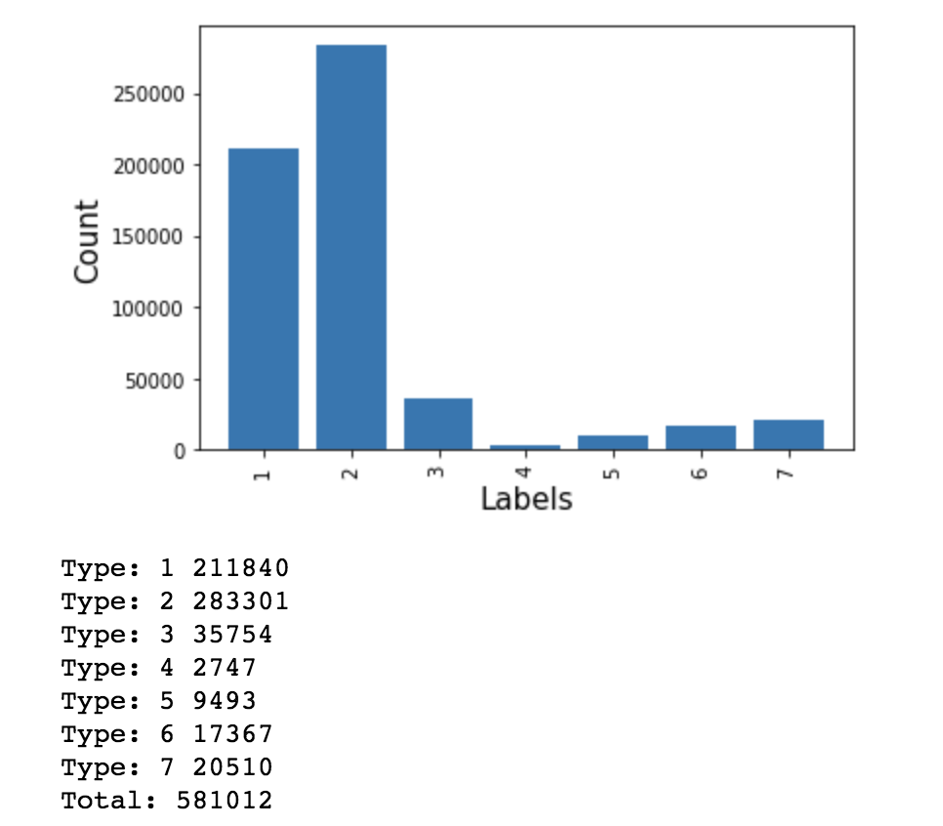

**Figure 6. Total number of samples for each cover type**

|  |  |  |  |
| --- | --- | --- | --- |
| Feature’s name | Measurement in units | Mean | Standard deviation |
| Elevation | Meters | 2959.36 | 279.98 |
| Aspect | Azimuth | 155.65 | 111.91 |
| Slop | Degrees | 14.1 | 7.49 |
| Horizontal distance to Hydrology | Meters | 1269.43 | 212.55 |
| Vertical distance to Hydrology | Meters | 46.42 | 58.30 |
| Horizontal distance to Roadways | Meters | 2350.15 | 1559.25 |
| Hill shade 9am | 0 to 255 index | 212.15 | 26.77 |
| Hill shade noon | 0 to 255 index | 223.32 | 19.77 |
| Hill shade 3pm | 0 to 255 index | 142.53 | 28.27 |
| Horizontal distance to Fire Points | meters | 1980.29 | 1324.19 |
| Wilderness Area | 0 (absence) or 1 (presence) | / | / |
| Soil types | 0 (absence) or 1 (presence) | / | / |

**Table 2. Summary statistics**

#### **3.1.2 Preprocessing**

##### **3.1.2.1 PCA**

The Figure 7 shows the influence of principal components number for each classifier on running time and accuracy. And the total explained variance for each principal component number is shown in the Figure 8. The range reduction of reduction number is from 2 to 10. In this section, only the PCA performance is analysed. Therefore, the K nearest number for KNN classifier is simply selected as well as the tree number for random forest classifier, which are 15 and 5 respectively.

For the running time, the increase of reduction number has a significant impact on the running time of random forest classifier, but rarely on the other two. For measuring accuracy, it is obvious that the accuracy for all of methods increases till their limitation, while the dimension is growing. It can be explained by total explained variance in the Figure 8. As the total explained variance becomes larger, more features are reserved, which will result in a better prediction.

In conclusion, considering the aspects including high performance and low execution time, we chose the optimal principal component number as 5 for KNN and random forest in the rest parts of analysis. And for logistics regression classifier, the prediction performance is not powerful enough with a small principal component number (E.g. Only around 0.6 in the range 2 to 5). Hence, we chose a larger principal component number for logistic regression, which is 10.

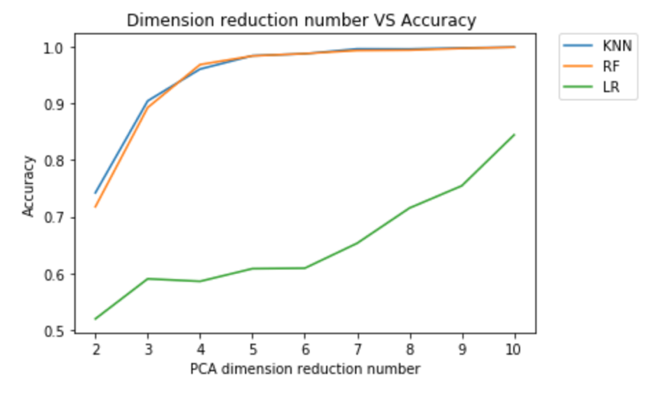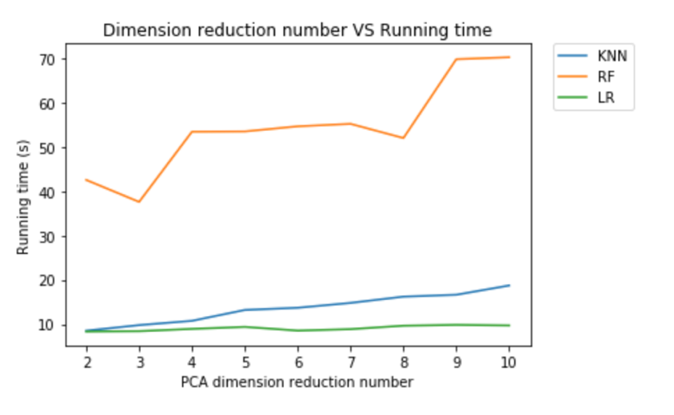

**Figure 7. Dimension reduction number vs Accuracy and Running time**

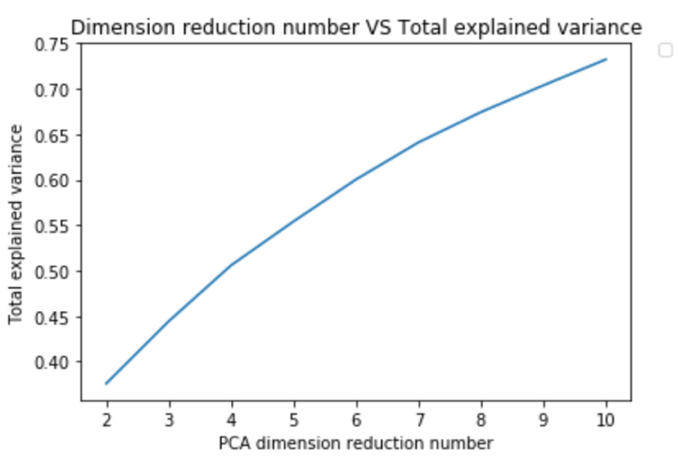

**Figure 8. Dimension reduction number vs Total explained variance**

##### **3.1.2.2 Normalization Range**

The Figures 9 displays the influence of rescale range on the accuracy of the classifier. The range is from (0,1) to (0,100) and only logistic is tested. Actually, even the range turned from 1 to 100, the accuracy fluctuates slightly at around 0.848. And the difference is around 0.004, which can be ignored. We can conclude that normalization range will not affect the prediction accuracy. Hence, for the rest parts, the default range (0, 1) is chosen.

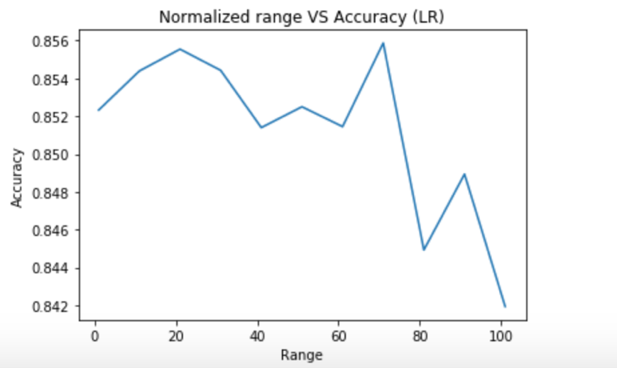

**Figure 9 Impact of normalized range on accuracy**

#### **3.1.3 Logistic Regression**

In Figure 10 shows the result with out normalization as a contrast. If only apply PCA on the original dataset, the accuracy would not be very high, which is approximately 60%. The serious problem is that only the three largest class can be predicted. The classes which only contain small numbers of records will be ignored by the classifier. One possible reason is shown in the warning saying that the coefficient did not converge because the maximum iteration was reached.



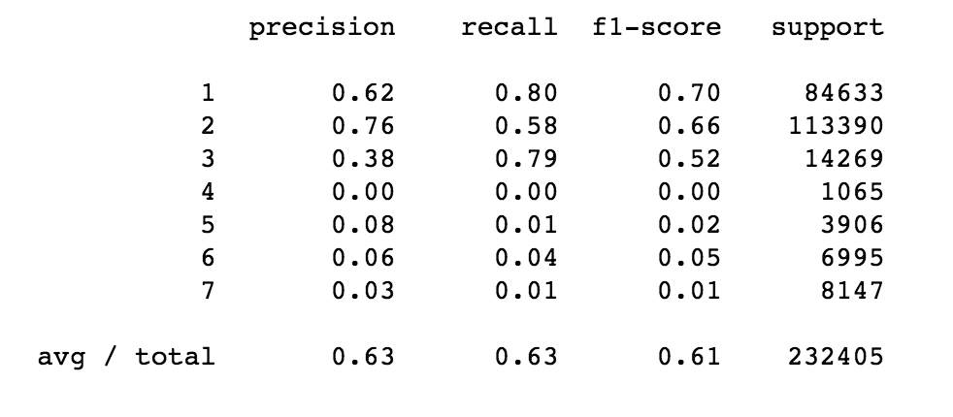

**Figure 10. The performance of the model before applying normalization**

Referring to the solutions of the previous work, the numbers of each class were changed to be the exactly same – 2500 samples. This step was aim at guaranteeing each class can be trained in an equal probability. However, the result of improvement was even worse, only about 50%, but all the types were predicted. Figure 11 displays the performance of this method.

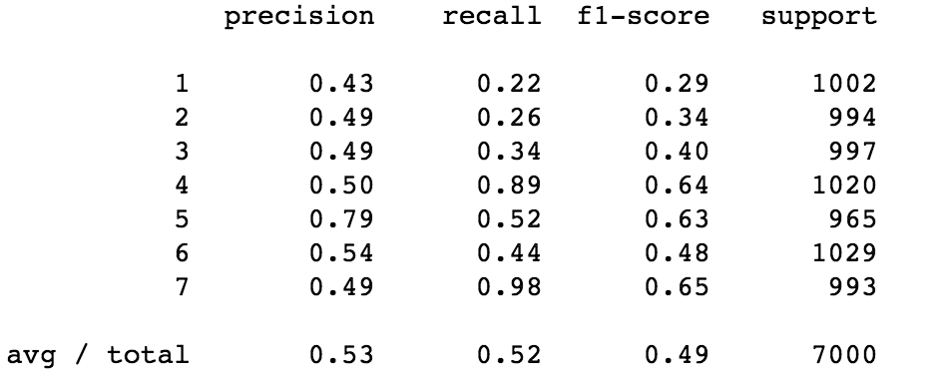

**Figure 11. The performance of the model by sampling the data**

To make logistic regression classifier achieve high prediction accuracy, we try different solver. saga is good for multiclass problems and can handle L1 penalty. Apart from adjusting the parameters in the Logistic Regression model itself, it is also important to investigate how the data pre-processing could influence on the model. As mentioned in the method section, one advantage of normalization is that the gradient decent converges perform faster with normalization. Hence, our best solution to is using the normalization to rescale the data set into range 0 to 1 and then execute the PCA. The results are that not only the the warning is disapear, but also the accuracy is above 80%.

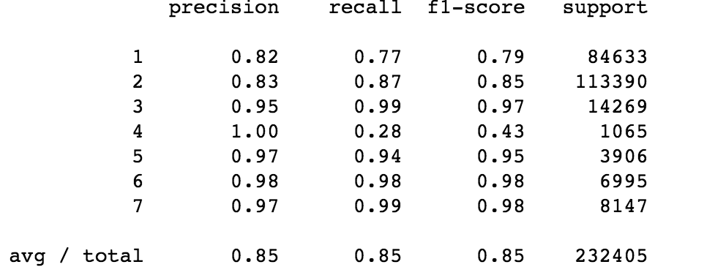

**Figure 12. The results after using normalizaion**

#### **3.1.4 K-Nearest Neighbor**

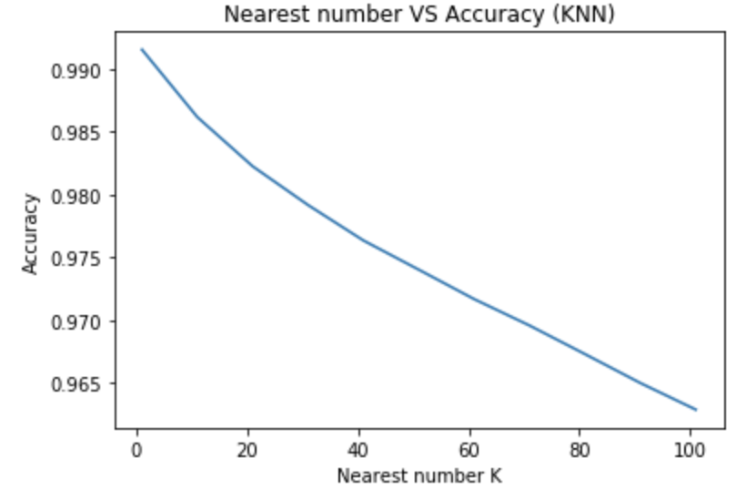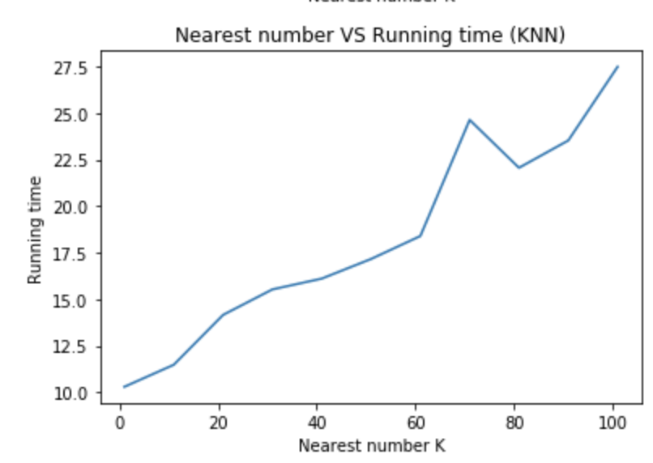

**Figure 13. The performance of KNN corresponding to the K nearest number**

In order to understand how different value of k impact on the accuracy of the classifier and the overall run time, we plotted the above two line-charts to show the correlation between those variables. As we could see on the left chart, when we choose the value of k ranges from 1 to 100, as the value of k increases, the accuracy of the classifier decreases. Then, we look at the run time of the program, as we can see, as the value of k goes up, the running time would also increase. The reason for such relationship is that when value of k increases, the sorting process becomes more complicated and it would cause more time.

In this classifier, we used optimal k of 1 for our KNN classifier to achieve high accuracy and efficient runtime. According to the above table, the overall accuracy of KNN classifier when k = 1 is 99.01%.

#### **3.1.5 Random Forest**

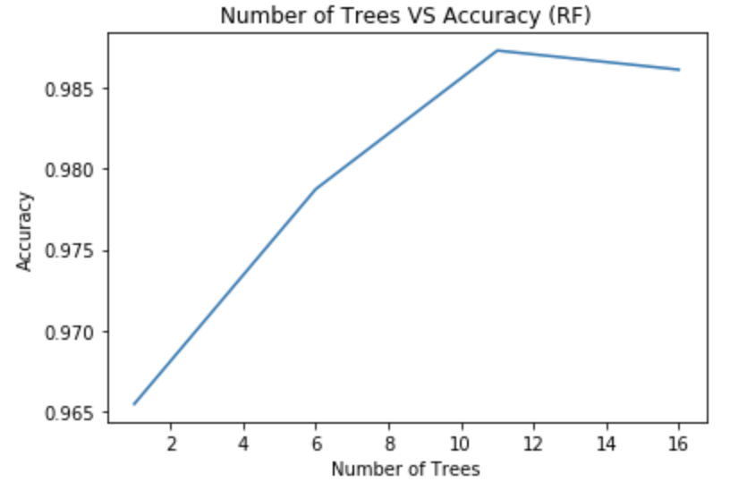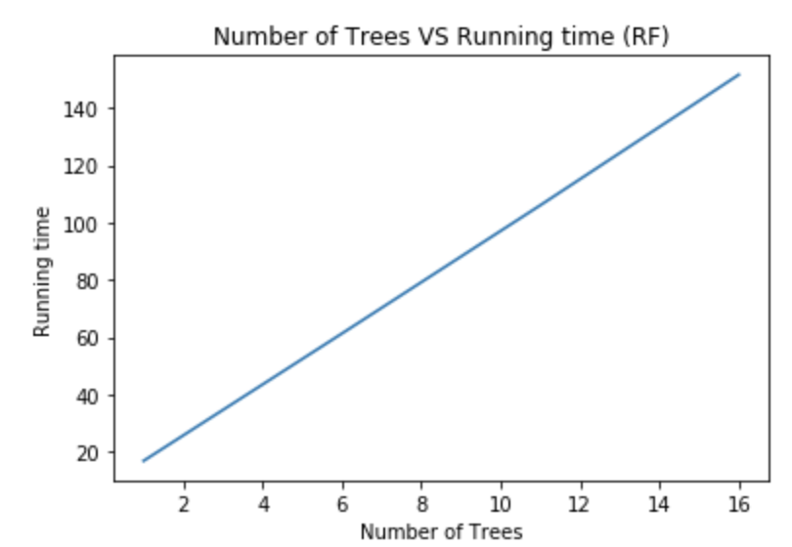

**Figure 14. The performance of Random Forest corresponding to the number of trees**

As for random forest classification we also performed normalization to the dataset. The above two line-plots shows the relationship between number of trees to accuracy and to running time. From the result shown above, in the range from 1 to 10, the accuracy is positive correlation with the number of trees. when the number of tree is around 10 to 12, the accuracy is stay around 0.983. According to the Figure 14, the running time increases as the number of trees increases.

When number of decision trees is increasing, more conditions are considered, and the process becomes much more complicated, which provides a better result and consumes more time.

In order to achieve a relatively good outcome and efficient performance, random forest classification was performed with five trees. The performance of the classifier reaches almost the accuracy of 98%.

### **3.2 Comparison and Discussion**

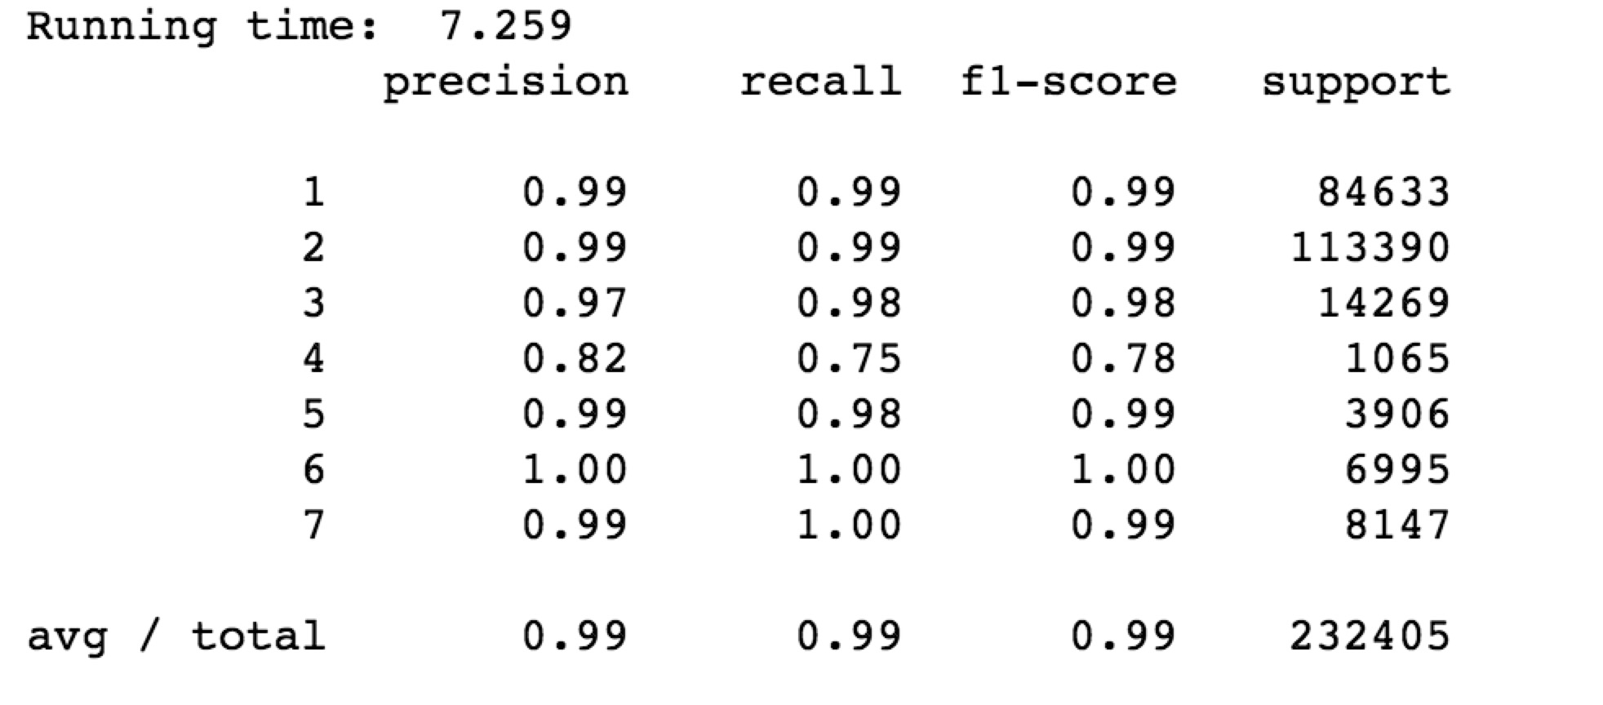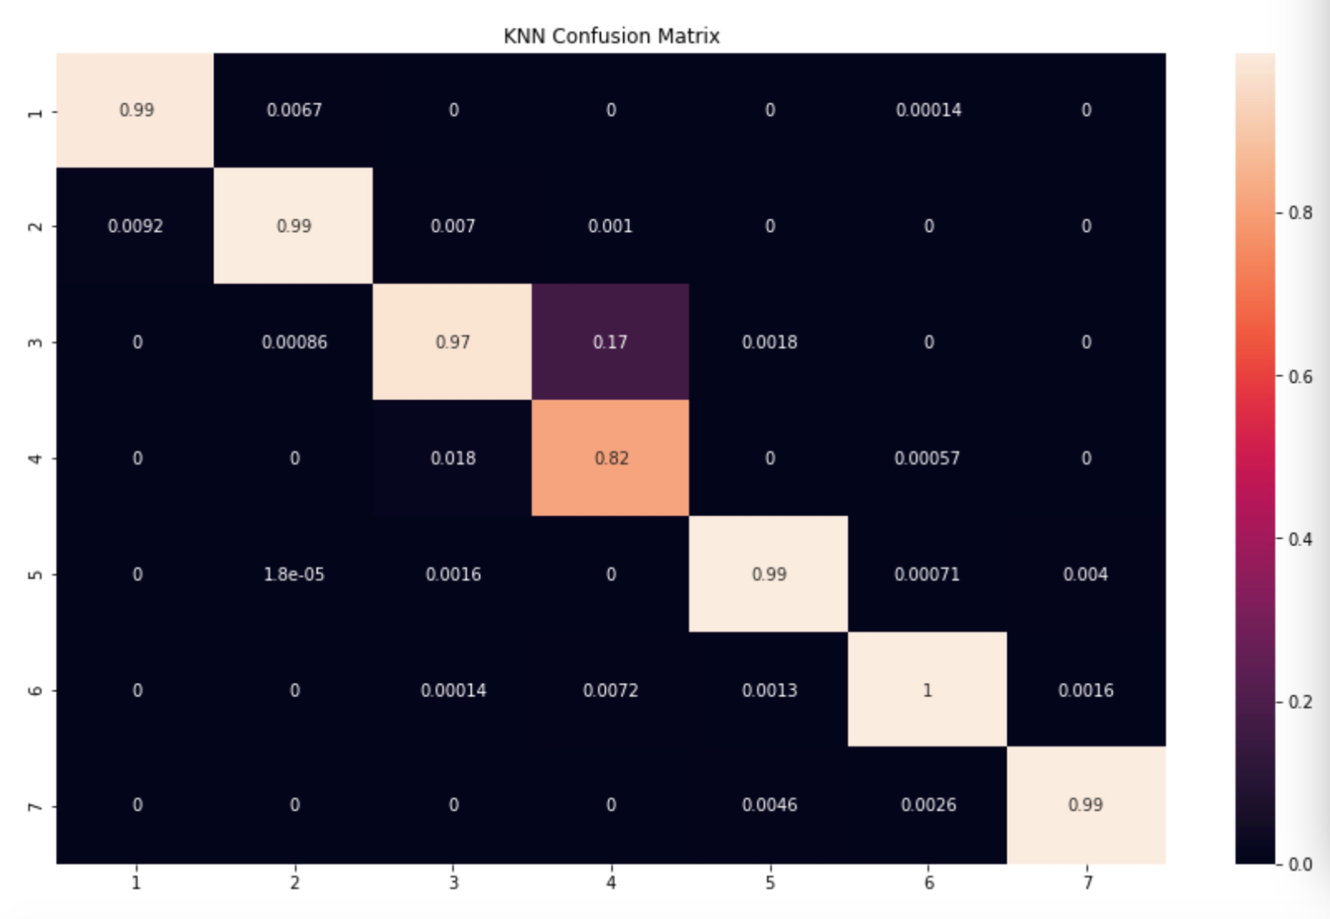**Figure 15. The result table and confusion matrix of Logistic Regression–with normalization**

**Figure 16. The result table and confusion matrix of KNN– with normalization**

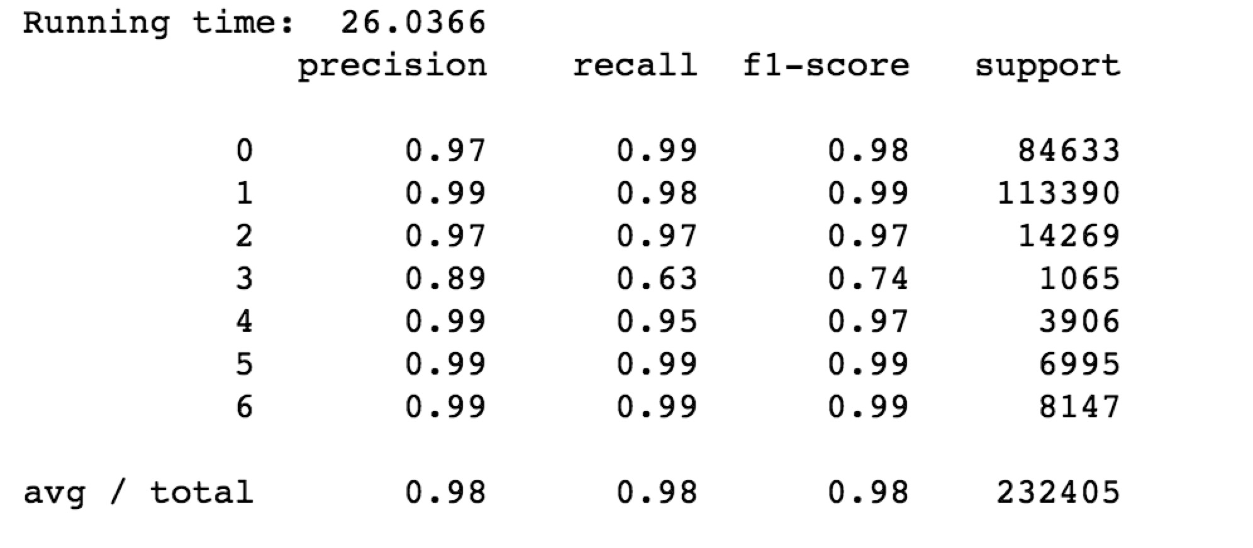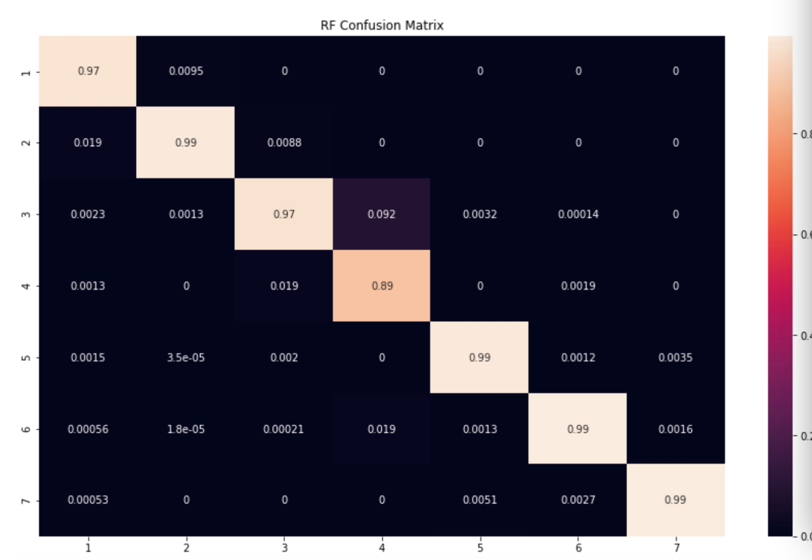**Figure 17. The result table and confusion matrix of Random Forest– with normalization**

The confusion matrixes of the three classifiers used are presented above. As we could see that among the three classification methods, KNN has the best accuracy performance by looking at the confusion matrix, which can also be referring to reported result in previous section. As for logistic regression, it has a relatively low accuracy rate compare to the other two methods and it also uses a higher number of PCA.

There is also interesting to find that for the fourth class it has a lower accuracy rate comparing to other classes. However, when we look closer to the data we found that the reason for causing this issue is that for fourth class – Cottonwood/Willow, it has the smallest number of record – 2747, with the total of 581012 records. Another reason might be there is a close similarity between the third class – Ponderosa Pine and the fourth class – Cottonwood/Willow. Due to the similarities between those two and the third class has significantly large number of record of 35754, few of fourth class item were classified as in third class for KNN and Random Forest methods. On the other hand, logistic regression model performs well for classify the type 4 class, but it has relatively low accuracy on classifying between type1 and 2 classes.

After running and comparing the three classification methods, we believe KNN is a better fit for this dataset. First of all, this dataset contains 581012 records, so it is not a very large dataset, in this case using KNN would fulfil the goal of classifying different classes. Secondly, by comparing the result for the three classification methods, KNN has the highest accuracy rate and with relatively low explained variance ratio, so that it need less information to make accurate classification. Thirdly, running time is also an important measurement, as we mentioned in our result section, KNN method has 7.2 seconds of running time, random forest has 26.0 seconds of running time and logistic regression classifier has 9.1 seconds of running time. Overall, according to the observations and performances, KNN method seems to be perform better than random forest method and logistic regression method on this dataset.

# **Conclusion and Feature work**

In this assignment, we successfully applied machine learning and data mining techniques to generate three types of classifiers to classify the classes in Cover type dataset. We tested logistic regression method, KNN algorithm method and random forest method. In order to improve the performance, we performed data preprocessing as normalization and PCA. Overall, all three of classifiers can have accuracy rate above 85%. Among the three classifiers, KNN seems to be the most accurate and efficient approach to make classification in this dataset.

There are few future work that one could perform on this dataset. Since KNN has such a high accuracy in this assignment when we use k=1, then it may have a chance of become overfitting. In this case, regularization can be performed on KNN classifier to prevent the likelihood of overfitting. A graph to help interpret the process of regularization is shown below:

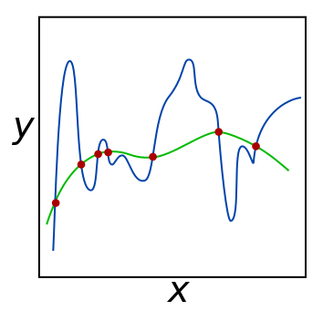

**Figure 18. An example diagram of overfitting**

For future work, we also suggest performing neural network to this dataset to minimize error and perform a more efficient classification by providing less amount of information.

**Reference**

[1] T. Kolasa and A. Raja, "Forest Cover Type Classification Study", Rstudio-pubs-static.s3.amazonaws.com, 2018. [Online]. Available: https://rstudio-pubs-static.s3.amazonaws.com/160297_f7bcb8d140b74bd19b758eb328344908.html. [Accessed: 01- Jun- 2018].

[2] H. Hugo, Classifying Forest Cover type with cartographic variables via the Sup- port Vector Machine, Naive Bayes and Random Forest classifiers., 1st ed. Örebro: Orebro University, 1992.

[3] R. Vasudev, "What is One Hot Encoding? Why And When do you have to use it?", Hacker Noon, 2017. [Online]. Available: https://hackernoon.com/what-is-one-hot-encoding-why-and-when-do-you-have-to-use-it-e3c6186d008f. [Accessed: 04- Jun- 2018].

[4] V. Spruyt, "The Curse of Dimensionality in Classification", Computer vision for dummies, 2014. [Online]. Available: http://www.visiondummy.com/2014/04/curse-dimensionality-affect-classification/. [Accessed: 04- Jun- 2018].

[5] L. Smith, "A tutorial on Principal Components Analysis", Cs.otago.ac.nz, 2002. [Online]. Available: http://www.cs.otago.ac.nz/cosc453/student_tutorials/principal_components.pdf. [Accessed: 04- Jun- 2018].

[6] S. Holland, "PRINCIPAL COMPONENTS ANALYSIS (PCA)", Strata.uga.edu, 2008. [Online]. Available: https://strata.uga.edu/software/pdf/pcaTutorial.pdf. [Accessed: 04- Jun- 2018].

[7] S. Ioffe and C. Szegedy, "Batch Normalization: Accelerating Deep Network Training by Reducing Internal Covariate Shift", Arxiv.org, 2018. [Online]. Available: https://arxiv.org/abs/1502.03167. [Accessed: 04- Jun- 2018].

[8] D. Abbott, Applied Predictive Analytics. Wiley, 2014, pp. 254-270.

[9] D. Benyamin, "A Gentle Introduction to Random Forests, Ensembles, and Performance Metrics in a Commercial System", Bing.com, 2012. [Online]. Available: http://www.bing.com/cr?IG=70006CA78D16421E87D8EEDB2DE67C09&CID=3D34AC24625068B23E09A7DA63AD69E7&rd=1&h=b5m98MAbg2aNXNhMnBGl3l0f_SpMlCtg5TJ2qmUmK1M&v=1&r=http%3a%2f%2fblog.citizennet.com%2fblog%2f2012%2f11%2f10%2frandom-forests-ensembles-and-performance-metrics&p=DevEx.LB.1,5504.1. [Accessed: 29- May- 2018].

[10] S. Polamuri, "How the random forest algorithm works in machine learning", Dataaspirant, 2017. [Online]. Available: http://dataaspirant.com/2017/05/22/random-forest-algorithm-machine-learing/. [Accessed: 29- May- 2018].

[11] J. Brownlee, "Bagging and Random Forest Ensemble Algorithms for Machine Learning", Machine Learning Mastery, 2016. [Online]. Available: https://machinelearningmastery.com/bagging-and-random-forest-ensemble-algorithms-for-machine-learning/. [Accessed: 04- Jun- 2018].

[12] R. Eulogio, "Introduction to Random Forests", Datascience.com, 2017. [Online]. Available: https://www.datascience.com/resources/notebooks/random-forest-intro. [Accessed: 29- May- 2018].

[13] "Covertype Data Set", Archive.ics.uci.edu, 2018. [Online]. Available: https://archive.ics.uci.edu/ml/datasets/covertype. [Accessed: 04- Jun- 2018].

# **Appendix**

**Code Instruction**

1. Open Jupyter notebook
2. Open the “Assignment2.ipynb”
3. Run the first eight cells, which contain all the necessary external libraries and all the defined functions
4. Load the data



1. Simply click the run bottom of the rest of the cells to get the results. E.g. After running the cells with comment “KNN classifier” at the beginning, it will provide the KNN classifier analysis
2. To get all the analysis, the simplest way is click Kernel > Restart & Run all

**External Libraries**

* Scikit-learn
* Pandas

**Data set URL**

https://archive.ics.uci.edu/ml/datasets/covertype